Viewforth High School


Standards and Quality Report 2025 - 2026
School Improvement Plan 2026 – 2027
Pupil Equity Fund Plan 2026 - 2027

Viewforth High School
Context of the School
Demographic
Viewforth High School is located in the east end of Kirkcaldy and serves a catchment area where there are a variety of socio-economic challenges facing the community. At the point of Census in September 2025, the school roll was 655. We have 34 learners within our Enhanced Support Classes, ranging from stages S1 – S6. 33.74% of our school roll is registered for Free School Meals, 68.55% have a recognized additional support need, 12.06% have English as an additional language and 4.73% are care experienced. We have a teaching complement of 63.85 FTE.
Viewforth High School shares the Windmill Community Campus with Rosslyn School, a public library, community use and the local community council office.
SIMD Profile
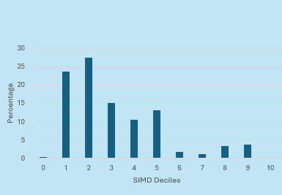
We have 4 Cluster Primary Schools, Dysart Primary, Kirkcaldy North Primary, Pathhead Primary and Sinclairtown Primary.
The Senior Leadership Team consists of 1 Head Teacher, 3 Depute Head Teachers and a Business Support Manager. There are 6 Principal Teachers of Curriculum and 6 Principal Teachers of Guidance
Our school values were revised during session 2024-2025 and are Respect, Equity, Ambition, Community and Health and we are working to promote these values throughout the school community of VHS. Our school vision is to Work Together, Achieve Together and we endeavour to be the best we can be, in all that we do.
Building the ambition, self-confidence and self-esteem of our young people is very important to us. By working closely as a school community and in partnership with parents/carers, the wider community and partner agencies, we aim to secure positive, sustained destinations for all of our young people; ensuring that pupils leave school having developed skills for life, learning and work and are ready to contribute positively within society.
In session 2025 – 2026 our key improvement priorities were centred on the Quality Indicators from HGIOS 4:
- 3.1 Ensuring Wellbeing, Equality and Inclusion
- 3.2 Raising Attainment and Achievement
- 3.3 Increasing Creativity and Employability

Attendance | Authorised (as 24.06.26) | 9.04% | Unauthorised | 7.57%
Exclusions | (as 24.06.26) Exclusions per 1000 – 5.18
Summary of consultation with stakeholders | - All staff consulted on the progress and impact of the 2025-2026 SIP.  - Faculty reviews of progress and impact of 2025-2026 FIPs.  - Pupil voice gathered through focus groups and questionnaires inc. in relation to the Anti-Bullying Policy, quality of learning and teaching and the curriculum pathway process.  - Parent voice gathered through questionnaires inc. in relation to the Anti-Bullying Policy, curriculum pathway process and the implementation of one to one devices.
Attainment Scotland Fund Allocation (PEF) | £169,560
Cost of the School Day statement | At Viewforth High School we recognise the need to reduce the Cost of the School Day for all our young people and particularly for our young people who are already experiencing poverty. We consider the cost of the school day through the following headings: Uniform, Travel, Learning, School trips, Eating and Clubs.

Summary of Progress and Impact from last session’s Improvement Plan and Next Steps

School Improvement Priority 1:
- Support and enhance the delivery of high-quality learning, teaching and assessment through professional learning for all staff on the use of digital technology.
- To support all staff through the use of digital technologies to create a more inclusive, engaging and personalised learning environment leading to improved outcomes for children and young people.
HGIOS 4 Quality Indicators:
1.3 Leadership of Change
2.2 Curriculum
2.3 Learning, Teaching and Assessment
2.6 Transition
3.2 Raising Attainment and Achievement
3.3 Increasing Creativity and Employability
Has this priority been:  (please highlight) | Fully achieved |  | Partially achieved | √ | Continued into next session
Progress

All teaching staff engaged in a structured programme of professional learning focused on the effective use of iPads to enhance learning, teaching and assessment. This was delivered by the local authority Transforming Learning team through a series of five one-hour sessions. To strengthen and sustain this learning, our Digital Leaders provided additional collegiate sessions, reinforcing key messages and supporting staff confidence and practice.
This comprehensive approach had a clear and measurable impact on classroom practice. Staff engagement with iPads increased notably over the course of the programme, reflected in observation data gathered during ‘Sharing the Learning’ windows. This demonstrated a 22% increase in the use of iPads in lessons, rising from 43% in Window 1 to 65% in Window 2, evidencing a positive shift in digital learning across the school.
Faculties demonstrated a commitment to this priority within the SIP through the development of targeted action plans. These plans identified specific approaches and detailed the intended impact within each faculty, providing clarity and direction. The targeted approaches included the use of tools such as Curipod to increase interaction and enable real-time feedback, accessibility features to support learner engagement, Book Creator to showcase and build portfolios of pupil work, and Showbie to share and structure learning activities.
Staff feedback indicates high levels of engagement, with almost all colleagues (92%) reporting that they are using iPads to enhance learning. Additionally, the majority of staff (78%) are now using the Showbie platform to set learning, collect pupil work and deliver timely feedback, leading to an increase in digital learning taking place across the school.
Faculty meeting minutes provide evidence of meaningful professional dialogue in this area, with the use of iPads to enhance learning featuring regularly as a standing agenda item. These discussions have supported the sharing of good and emerging practice, reflection on local authority professional learning, exploration of digital tools to improve learner engagement, and the development of practical strategies to maximise readiness for learning, including ensuring pupils arrive to class with fully charged devices.
Opportunities to extend professional learning have been made available through Career Long Professional Learning (CLPL), including access to self-directed learning via the Apple Education Community and Microsoft Learn, alongside other digital platforms. To date, 38% of staff have engaged with these opportunities, reflecting a growing commitment to developing digital pedagogy. Capacity is being further strengthened through the development of in-school expertise, with our Digital Lead having recently completed the Apple Education Trainer qualification. This will enhance our ability to provide targeted, sustainable support and further increase staff confidence and engagement.
The appointment of a Digital Lead has played a key role in driving forward the implementation of iPads. They have provided high-quality, responsive support to teachers at individual and faculty level, including the delivery of professional learning and the introduction and embedding of Showbie as a core digital learning platform. Their work has been instrumental in supporting staff to develop their understanding and confidence in integrating digital tools into their practice.
A parental engagement session was held to strengthen home–school partnerships and provide insight into how iPads are being used to support learning at Viewforth. The session offered staff the opportunity to share practical examples of digital learning in action, including how work is set, accessed and completed from a pupil perspective. This helped parents gain a clear understanding of how learners engage with tasks and manage their learning using digital tools.
The evening also showcased the range of accessibility features available on the iPads to support learners’ needs, reinforcing our commitment to meet the needs of all learners within our community. In addition, it provided a valuable platform for dialogue, enabling parents to ask questions, seek clarification and build confidence in how digital learning is enhancing their child’s educational experience at VHS.

Impact
Evidence gathered through our Sharing the Learning experience windows and a local authority learning partnership visit indicates that the introduction of digital tools has had a positive, though not yet consistent, impact on learner engagement and progress. In line with How Good is Our School? 4 (QI 2.3: Learning, Teaching and Assessment and QI 3.2: Raising Attainment and Achievement), effective practice was observed where digital approaches were well embedded. In these contexts, learners demonstrated increased motivation and engagement, with Showbie identified as a particularly effective tool in supporting retrieval practice and providing timely, high-quality feedback.
These findings are further supported by pupil voice gathered through questionnaires and focus groups, which included a representative range of learner views. While views varied, there was a clear recognition of the benefits of digital learning when used effectively. Encouragingly, across all year groups, almost all pupils (92%) reported confidence in their ability to use iPads to support and enhance their learning. This indicates strong progress in developing learners’ digital skills and aligns with the school’s commitment to improving outcomes through high-quality, digital learning experiences.
In March 2026, a representative survey of 200 pupils from S1 to S6 provided valuable insight into the impact of iPads and digital platforms on the learner experience. In the Broad General Education, most pupils (79%) reported that they value using Showbie to support their learning, with regular and effective use identified across key subjects including Mathematics, Social Subjects, Spanish and English. In line with How Good is Our School? 4 (QI 2.3: Learning, Teaching and Assessment), this reflects growing consistency in the use of digital tools to support learning. The majority of pupils (50%) indicated that learning is more engaging when using their iPad, while a strong majority (78%) reported that digital approaches are helping them to develop greater independence in their learning, demonstrating positive progress in independent learning and skills for learning (QI 2.2: Curriculum).
Beyond the classroom, most pupils (80%) reported using their iPads at home to support their learning, with the majority (55%) using the device to complete homework and reinforce learning. This highlights the positive impact of digital learning in extending learning beyond the school day and supporting continuity (QI 3.2: Raising Attainment and Achievement). In the Senior Phase, engagement with iPads at home is less consistent, with 42% of pupils reporting regular use. However, where iPads are used, this continues to be most evident in Social Subjects, English and Mathematics, indicating areas of effective practice that can be built upon to further strengthen consistency and maximise impact across all year groups.
Awareness of accessibility tools is strong across the school, with most pupils in both the Broad General Education (90%) and Senior Phase (84%) reporting that they are familiar with the range of supports available. However, evidence indicates that there is scope to further strengthen the impact of accessibility tools, with less than half of pupils currently identifying that these tools support their learning (34%) or expressing confidence in how to maximise their use (27%). Targeted interventions are demonstrating positive impact. A focus group of learners with a dyslexia diagnosis who received additional training highlighted the positive role of accessibility tools in reducing barriers to learning and promoting independence. Pupils shared practical examples of how features such as speech-to-text and visual adjustments support their engagement, alongside valuing the ability to blend into the rest of the class without the needs for coloured overlays etc.
Lesson observations evidence a commitment to inclusive and equitable practice, with appropriate alternatives consistently provided where technology is unavailable. This ensures equity of access and reinforces that digital tools are used to enhance, rather than limit, learning experiences.
Staff confidence in the use of digital tools continues to develop positively. Most staff (77%) reported increased confidence as a result of engagement in CLPL, with over a quarter (27%) identifying a significant improvement. This professional learning has been delivered through a combination of in-school collegiate sessions and a structured programme provided by the local authority Transforming Learning team. Lesson observations indicate that while the impact of iPad use on the quality of learning and teaching remains variable, there is growing consistency in key areas. Staff demonstrate a clear understanding of school and faculty digital learning priorities, and established routines and expectations for iPad use are evident across the school. This suggests that digital technology is being integrated in a purposeful and considered way in VHS, supporting learning and complementing already established effective strategies.
Staff voice questionnaires indicate strong and growing confidence in the use of digital tools to support learning. Most staff (76%) reported that they are confident in using Showbie to distribute assignments, collect pupil work and provide feedback, while a majority (56%) are using Curipod to facilitate real-time feedback and enhance learner engagement. This is further reinforced by findings from the Glasgow Motivational Wellbeing Profile, with almost all pupils (91%) reporting that staff recognise and share their strengths in learning at least some of the time. Overall, the majority of staff (56%) believe that iPads are having a positive impact on learners’ ability to learn effectively.
A parental questionnaire issued in March, which received 40 responses, provides further insight into engagement with digital learning beyond the classroom. The majority of respondents (72%) reported that their young person uses their iPad at home to complete homework and support study, highlighting the role of digital tools in supporting learning at home. Over half of parents (54%) have been introduced to Showbie by their child, supporting home–school connections in learning. While most parents (81%) are aware of accessibility tools, views on the overall impact of iPads on learning in school are more varied. Less than half (41%) believe that iPads are improving their young person’s learning, with a further 31% unsure. This indicates a need to continue to build parental understanding of the impact of digital learning, ensuring greater consistency in how its benefits are communicated.
Next Steps

Revisit, consolidate and strengthen professional learning to focus on the impact of digital tools on learning, teaching and assessment, with an emphasis on questioning, meeting diverse needs and the effective use of accessibility tools.
Enhance consistency across the school by agreeing and embedding a small number of focused approaches including the use of Showbie for all learners in S1-S3.
Continue to engage with parents and carers to strengthen understanding of the impact of digital learning and develop their skills and confidence in how they can support their children at home.

School Improvement Priority 2: Raising Attainment and Achievement
HGIOS 4 Quality Indicators:
  - Self-evaluation for self-improvement
  - Leadership of change
2.1 Safeguarding and child protection
2.4 Personalised support
3.1 Ensuring wellbeing, equality and inclusion
3.2 Raising attainment and achievement
Has this priority been:  (please highlight) | Fully achieved |  | Partially achieved | √ | Continued into next session
Progress

During session 2025–2026, Viewforth High School has made significant progress in strengthening systems, practice and outcomes aligned with HGIOS4 Quality Indicator 3.2 – Raising Attainment and Achievement. This work has been underpinned by a strategic focus on robust tracking, targeted interventions and high expectations for all learners.
A key priority this session has been the successful implementation of the authority-wide Sequential tracking system (Didbook), used in all Primary and Secondary schools across Fife. The system is now embedded across the school, with almost all staff using the system as per the school calendar to track and report on young people’s progress. Further work is required to incorporate our Secondary Enhanced Provision into the Didbook system.
Comprehensive staff training was delivered during the August In-service day, supported by faculty-based sessions and the development of a school-specific guidance resource and this has supported consistency and confidence in the system’s use across our staff team.
The use of tracking data has enabled a more rigorous and responsive approach to monitoring progress, with regular scrutiny of attainment information leading to timely and targeted interventions for learners, particularly those at risk of underachievement.
This strengthened approach to data use reflects strong alignment with HGIOS4 QI 3.2, particularly in:
- Using data effectively to identify gaps in attainment
- Targeting interventions to improve outcomes
- Supporting equity through identification of key learner groups

Professional learning has been central to continuing to improve outcomes for our young people. Through structured opportunities such as PTC/PTG seminars and collegiate sessions, staff have developed greater confidence in analysing and interpreting attainment data, including generating bespoke insights to meet faculty and learner needs.
Regular tracking meetings involving the 3.2 DHT, HT and PTCs for literacy and numeracy have strengthened collective accountability for progress in literacy and numeracy, ensuring a consistent focus on attainment across the school. This work demonstrates progress in building staff capacity to evaluate impact.
The school has implemented innovative and flexible curriculum pathways to maximise attainment for targeted groups of learners. This includes the introduction of bundled SCQF Level 5 courses (e.g. Barista, REHIS, Creative Industries) designed to improve attainment outcomes for those at risk of not attaining.
Additionally, the appointment of a Principal Teacher of Outreach has enhanced the support we can provide for young people furthest from attainment, complementing existing provision such as the Employability Hub and Attainment Group.
This targeted approach aligns strongly with HGIOS4 QI 3.2 expectations around:
- Equity and inclusion
- Closing the poverty-related attainment gap
- Ensuring appropriate pathways for all learners

A consistent message has been communicated across the school community that all young people should be supported to achieve at the highest possible level, reinforced through the school’s aspirational presentation policy and alignment with our school value of Ambition. Clear and regular communication with parents and carers (HT weekly update, PTC and PTG calls and emails) alongside online resources, further strengthened the home-school partnership in supporting attainment.
To support attainment, a wide range of study support opportunities were developed, including:
- After-school and lunchtime sessions across most curricular areas
- Targeted Friday study sessions in the lead-up to the Qualifications Scotland exam diet
- Structured “How to Study” inputs within the PSE programme

Learner conversations have been embedded within the school’s tracking and reporting calendar, supporting young people to better understand their progress and next steps. While engagement with learner conversations has been strong in the Senior Phase, evaluation has highlighted a need for greater consistency across the Broad General Education (BGE). However, this work represents an important step towards ensuring that learners:
- Understand their strengths and areas for development
- Are active participants in their learning
- Take increasing ownership of their progress

Significant progress has also been made in strengthening teacher professional judgement and moderation, supporting more reliable and confident ACEL data. Staff engagement in the Kirkcaldy Collaborative and authority-wide moderation activities has been strong, with time prioritised for this work in our collegiate calendar.
At an Extended Leadership Level, participation in the PTC Network Meetings and regular literacy and numeracy ACEL meetings has ensured a more consistent approach to tracking and reporting within the BGE. Monthly tracking discussions and benchmarking against similar schools have supported challenge, consistency and continuous improvement, with a clear focus on attainment in literacy and numeracy.
Overall, the school has made strong progress in improving systems and practice to raise attainment, with clear evidence of:
- More robust and consistent tracking systems
- Increased staff confidence in data use and moderation
- More targeted and equitable interventions
- A strengthened culture of high expectations and ambition
- Greater learner engagement in understanding their progress

While further work is required to ensure consistency in learner conversations across all stages and to maximise engagement with study support, the foundations established this session place the school in a strong position to continue improving outcomes for all young people.
Impact
Throughout session 2025–2026, the actions undertaken by Viewforth High School have led to measurable improvements in young people’s attainment, engagement and understanding of their progress in learning.
There is strong evidence of improving attainment in both literacy and numeracy, particularly within the Senior Phase. The proportion of young people achieving Level 5 Literacy in S4 has increased significantly, rising from 47.3% in 2024 to a projected 64.8% in 2026. Similarly, numeracy attainment at Level 5 continues to improve, with projected outcomes closely aligned with stretch targets and exceeding comparator measures.
Within the Broad General Education (BGE), Achievement of Curriculum for Excellence Levels (ACEL) data shows notable improvement, particularly at Level 4 literacy, where outcomes have strengthened significantly across reading, writing and listening and talking. These improvements demonstrate that targeted interventions and improved tracking are positively impacting attainment outcomes, a central feature of our work within Quality Indicator 3.2.
Targeted curriculum pathways and interventions have had a direct impact on raising attainment for learners who require additional support. Young people participating in tailored SCQF Level 5 courses, such as Barista, Creative Industries and REHIS, have achieved recognised qualifications, with the majority securing at least two Level 5 awards—often representing their only qualifications at this level. In addition, targeted outreach support has contributed to improved outcomes for learners at risk of not attaining, with many young people within key target groups (incl. SIMD 1 and 2, FME and CE) achieving multiple qualifications.
This demonstrates clear progress in:
- Improving outcomes for targeted groups
- Reducing barriers to attainment
- Ensuring appropriate pathways for all learners

There is strong evidence that young people have a greater understanding of their progress and next steps in learning. All senior pupils who participated in focus groups reported that they knew where they were in their learning and what they had to do to improve, demonstrating an increased sense of ownership and clarity.
Similarly, learner conversations and improved tracking processes have supported young people to:
- Recognise their current level of attainment
- Identify next steps for improvement
- Engage more meaningfully in their learning

This progress reflects a key expectation of QI 3.2, where learners are active participants in understanding and improving their attainment.
The use of detailed tracking data has enabled the school to identify and respond to the needs of specific learner groups, including those with additional support needs or facing socio-economic disadvantage. As a result, interventions are now more targeted and responsive, supporting improved outcomes for almost all learners. Young people are increasingly aware of support strategies available to them, and the majority report being able to take greater ownership of their learning as a consequence of this targeted support.
A more flexible and responsive curriculum has enabled young people to access pathways that better meet their needs and aspirations, leading to improved attainment outcomes. Evidence shows that more learners are being challenged appropriately and supported to achieve at the highest possible levels, with examples of significant individual success, including learners achieving multiple Level 5 qualifications through appropriately challenging pathways.
This reflects strong alignment with QI 3.2 through:
- Appropriate levels of challenge
- Inclusive curriculum design
- Recognition of wider achievement

Young people report feeling well prepared for assessment and examination processes, supported by clear communication and structured preparation. All learners involved in focus groups indicated that they felt prepared for their prelim examinations, reflecting the effectiveness of guidance and support provided. Additionally, young people demonstrated increased independence in their study approaches, with most reporting the use of a range of study methods to support their revision.
Learner conversations and revised tracking and monitoring approaches have had a particularly strong impact in the Senior Phase, where:
- All senior pupils reported participation in learning conversations
- Pupils valued one-to-one discussions with teachers
- Feedback was used to inform preparation for assessments and exams

This demonstrates a positive impact on learner confidence and engagement, and we believe will continue to support improved outcomes for young people in the future.
While strong progress has been made, evaluation evidence highlights areas requiring further development:
- In the BGE, a significant proportion of S2 pupils do not yet have a clear understanding of their strengths and next steps, indicating inconsistency in learner experiences
- Engagement in study support is variable, with attendance declining over time and greater participation from learners already on track
- Some priority groups (e.g. Care Experienced and Free School Meal learners) remain underrepresented in higher-level attainment pathways, indicating the need for further targeted intervention

These insights provide a clear and evidence-based focus for continued improvement in line with QI 3.2.
Overall, the evidence demonstrates that the school’s improvement work has led to:
- Improved attainment outcomes, particularly in literacy and numeracy
- Greater equity in attainment and achievement, through targeted pathways and interventions
- Increased learner understanding and ownership of progress
- Improved preparedness and confidence in assessments

This represents strong and measurable progress in delivering the expected outcomes of this priority within our School Improvement Plan as well as the expectations of HGIOS4 Quality Indicator 3.2 – Raising Attainment and Achievement, with a clear plan for continued improvement.
Next Steps

Embed the use of Didbook insights in all faculties to ensure interventions are timely, targeted and improve attainment over time.

Implement a consistent whole-school learner conversation model across BGE and Senior Phase and develop staff capacity to ensure these are high quality and impactful.

Further develop moderation processes at faculty, cluster and authority level to ensure consistent standards and continue to increase staff confidence in making robust, holistic ACEL judgements across all eight curricular areas.

Explore and implement more engaging and effective approaches to study support to improve uptake and impact.

Ensure assessment timelines are fully aligned with reporting processes to support accurate and timely tracking of progress.

School Improvement Priority 3: Increasing Creativity and Employability
HGIOS 4 Quality Indicators:
1.2 Leadership of Learning
1.3 Leadership of Change
2.2 Curriculum
2.3 Learning, Teaching and Assessment
2.6 Transitions
3.1 Ensuring wellbeing, equality and inclusion
3.2 Raising attainment and achievement
Has this priority been:  (please highlight) | Fully achieved |  | Partially achieved | √ | Continued into next session
Progress

Over the course of session 2025–2026, Viewforth High School has made meaningful progress in strengthening a culture of wellbeing, positive relationships and inclusion. This work has been driven by a clear commitment to ensuring that all young people feel safe, respected and included, aligned with HGIOS4 Quality Indicator 3.1 (Ensuring Wellbeing, Equality and Inclusion) and supported through targeted approaches to personalised support (QI 2.4).
A key focus has been building staff confidence and clarity in responding to wellbeing needs, particularly in relation to bullying and attendance. Training on the revised Anti-Bullying Policy was delivered to all staff and revisited across the session, with further targeted input for our support staff. As a result, almost all staff report a clear understanding of their responsibilities in responding to bullying, and most are confident in reporting procedures.
This demonstrates strong progress within QI 3.1, where staff share a consistent understanding of expectations and contribute to a safe and supportive environment. In addition, the clarity of roles across teaching, support and leadership staff has strengthened collective responsibility for supporting young people.
Targeted work with young people has focused on increasing their awareness of bullying and how to report concerns. Assemblies, PSE inputs and focused work during Anti-Bullying Week have ensured consistent messaging across all year groups. Following a targeted assembly input, almost all young people were able to clearly explain how to report bullying, illustrating improved confidence and understanding. This reflects positive improvement, particularly in empowering young people to exercise their rights and feel confident in seeking support.
Regular analysis of bullying incidents has been undertaken to identify patterns and inform targeted responses. While this has strengthened the school’s understanding of reported incidents, further work is required to improve the consistency of recording and follow-up processes.
In relation to attendance, analysis highlighted that barriers are often complex and, in some cases, linked to factors beyond the school’s direct influence, including family routines and anxiety. This has led to a more nuanced understanding of need, supporting the school’s approach to QI 2.4, where support is increasingly responsive to individual circumstances.
Evidence from the Glasgow Motivation and Wellbeing Profile survey indicates that most young people feel safe, respected and included within the school. Improvements are evident across key measures, including feeling safe, feeling listened to, and feeling that adults care and provide support.
There has also been a positive increase in the number of young people who report feeling confident to raise concerns about bullying, with improvements noted across all key groups.
Communication with parents has been strengthened through newsletters, engagement with the Parent Council and signposting to online resources. Parent feedback indicates that most feel the school listens to concerns about bullying, with a majority expressing confidence in the school’s responsiveness.
Although the overall attendance target for S3 was not achieved, significant progress has been made in strengthening targeted support approaches. The school has reviewed and restructured its support provision, establishing two distinct pathways:
- A Learning Plaza, focused on supporting engagement with learning and reinforcing positive learning behaviours
- A Pupil Support Classroom, providing a safe, nurturing environment for those requiring support with emotional regulation and readiness to learn
Early evidence indicates that most young people accessing these provisions have experienced improved or stabilised attendance since implementation, with notable improvements for many individuals.
While progress has been significant, there are areas requiring continued focus:
- Completion of the Respect Me Reward process remains outstanding
- Further consistency is needed in the recording and follow-up of bullying incidents
- Whole-school approaches to improving attendance require greater consistency and sustained focus, particularly at universal level
Overall, the school has made clear and measurable progress in promoting wellbeing, relationships and inclusion. There is strong evidence that most young people feel safe, respected and supported, with improved staff confidence and increasingly targeted approaches to meeting learners’ needs.
Moving forward, we will continue to strengthen universal and targeted supports, ensuring that improvements are sustained and that all young people benefit from consistent, high-quality experiences in line with HGIOS4 Quality Indicators 2.4 and 3.1.
Impact

During session 2025–2026, the work undertaken to promote positive relationships and inclusion has led to measurable improvements in young people’s experiences of safety, respect and belonging, demonstrating clear alignment with HGIOS4 Quality Indicators 2.4 and 3.1.
Data from the Glasgow Motivation and Wellbeing Profile (February 2026) shows that most young people feel safe sometime or all of the time, with the majority (56%) reporting that they feel safe all of the time and only a few (8%) indicating that they do not and our Principal Teachers of Guidance have followed up with these young people individually.
There is a positive trend over time, with an increase in the highest ratings of feeling safe compared to the baseline in September. This improvement is evident across key groups, including young people in receipt of Free School Meals, where the proportion reporting feeling safe all of the time has increased.
In addition, most young people report that adults look out for them and ensure their wellbeing, with over half indicating this is consistently the case and improvements seen across all identified groups.
Together, this demonstrates strong progress within QI 3.1, evidencing that the school is fostering a safe, nurturing environment where young people feel cared for and supported.
There has been a notable increase in young people’s confidence to report concerns, including bullying. Survey data shows a rise in the number of pupils indicating they would complain if they felt picked on, with improvements across all targeted groups (ASN, Care Experienced, Free School Meals).
This increase in the confidence of young people to report concerns reflects both improved awareness and a growing sense of trust in our systems and processes. This is a key indicator of progress within QI 3.1, where learners feel empowered to exercise their rights and seek support when required.
Survey data indicates that an increasing number of young people feel listened to within the school, with nearly half reporting this is consistently the case and an overall increase in the highest ratings across all groups. While a minority of young people still report that they do not always feel listened to, the overall trend is positive, suggesting that improvements in staff awareness, communication and relational practice are beginning to impact meaningfully.
Young people’s sense of belonging has also improved, with an increase in those reporting that they feel they belong to the school or are important to the school community. Although fewer than half of young people report feeling a strong sense of belonging all of the time, the overall direction of travel is positive, with increases in the highest ratings across all groups.
This demonstrates progress within QI 3.1, while also highlighting the need for a continued focus on ensuring that all learners experience a strong and consistent sense of inclusion.
While the overall attendance target for S3 was not achieved (78.36% as of June 2026), there is strong evidence that targeted, personalised interventions are having a positive impact on individual engagement and attendance.
The introduction of the Learning Plaza and Pupil Support Classroom has resulted in:
- Most young people in the Pupil Support Classroom experiencing consistent or improved attendance following implementation
- The majority of learners accessing the Learning Plaza showing significant improvements, with attendance rising from an average low of 60.95% to 89.42% since January
- When extended to S4, attendance among these learners improved further to an average of 90.64%
This demonstrates a strong impact of personalised, needs-led support, clearly aligning with QI 2.4, where tailored interventions are improving outcomes for young people at risk of disengagement.
In addition, school observations indicate a reduction in internal truancy and increased engagement in learning, suggesting that these targeted approaches are contributing to improved participation and behaviour across the school.
Feedback from both parents and young people indicates increasing confidence in the school’s approach to addressing bullying:
- Most young people report that the school listens to concerns and takes action
- A majority of parents feel listened to, with a positive overall perception of the school’s response to bullying concerns
This demonstrates improving partnership working and trust, supporting progress within both QI 3.1 and QI 2.4.
Overall, the evidence demonstrates that the school has made good progress in improving wellbeing, relationships and inclusion. Most young people now report positive experiences in relation to safety, support and respect, and there is clear evidence that targeted interventions are beginning to reduce barriers to engagement for those most at risk.
While some variability remains—particularly in relation to attendance and consistent experiences of belonging—the positive trends across multiple data sources provide strong evidence of sustained improvement.
The impact of this improvement priority is evident in both quantitative data and qualitative feedback. There is evidence that most young people feel safer, more supported, and more confident to engage with staff and their learning.
The next phase of work will focus on ensuring greater consistency across all learner groups, further strengthening universal approaches while continuing to build on the success of targeted interventions, ensuring that all young people benefit fully from the school’s inclusive ethos and support systems.
Next Steps
Complete the Respect Me Reward through the establishment of a short-life working group, ensuring meaningful engagement with young people and aligning practice with updated local authority guidance.

Review and update the Anti-Bullying Policy to reflect current national and local expectations, further embedding consistent, rights-based approaches to promoting positive relationships and inclusion.

Strengthen universal approaches to attendance through a renewed focus on relational practice and the CIRCLE framework, ensuring consistent, high-quality support for all learners (linked to Cluster Improvement Plan).

Refine targeted interventions for attendance, ensuring that support is proportionate, needs-led and sustainable, particularly for young people at risk of disengagement and strengthen partnership working with the local authority to refine attendance systems, including coding and processes for late-stage intervention where engagement is limited

Revisit the continuum of support to ensure clarity, consistency and shared understanding across all staff, leading to improved outcomes in wellbeing, inclusion and attendance (linked to Cluster Improvement Plan).

Improving Outcomes

Attainment

S3 CfE Declarations
Stage | Listening and Talking | Reading | Writing | Numeracy
S3 (Level 3) | 81.06% | 81.06% | 81.06% | 80.30%
S3 (Level 4) | 65.91% | 65.91% | 65.91% | 71.97%

S4 Literacy & Numeracy
Level/Measure | Literacy |  | Numeracy
 | Stretch Target | Actual | Stretch Target | Actual
Level 3 | 95.8% | 94.44% | 97.20% | 94.44%
Level 4 | 92.4% | 90.97% | 95.8% | 88.89%
Level 5 | 65.3% | 59.72% | 64.6% | 64.58%

CfE Declarations
- By the end of S3, most young people achieved Level 3 in Reading (81.06%), Level 3 Reading (81.06%) and Level 3 Writing (81.06%). Most young people also achieved Level 3 Numeracy (80.30%) by the end of S3.
- By the end of S3, the majority of young people achieved Level 4 Listening and Talking (65.91%), Level 4 Reading (65.91%) and Level 4 Writing (65.91%). This is a significant increase from session 2024-2025 when the minority of young people achieved Level 4 literacy outcomes by the end of S3 – Listening and Talking (31.5%), Reading (41.3%) and Writing (39.2%). The majority of young people achieved Level 4 Numeracy (71.97%).
- We will continue to work to ensure that our S3 CfE ACEL levels are in line with BGE expectations and also align with National Expectations for the Senior Phase.

Senior Phase Literacy and Numeracy
- VHS continues to have almost all young people in S4 achieving Level 4 Numeracy (session 25/26 = 94%), session 24/25 = 91.10%, session 23/24 = 92.57%, session 22/23 = 93.71%) consistently about the virtual comparator.
- In S4, at Level 5 Numeracy, the majority of our young people achieved Level 5 Numeracy over the past five years (session 25/26 = 65%, session 24/25 = 62.33%, session 23/24 = 59.46%, session 22/23 = 71.33%, session 21/22= 59.86%)
- In two out of the last five years, almost all of our young people have achieved Level 4 Literacy by the end of S4 (session 22/23 and 25/26). In the remaining three years from five, the majority of young people achieved Level Literacy by the end of S4.
- There has continued to be an improvement in Level 5 Literacy with the majority of young people achieving Level 5 by the end of S4 (61%). Improved consistency and accuracy in tracking has supported this increase.

Breadth v’s Depth
- Viewforth HS continues to offer most of our young people 5 passes at Level 3+ (session 2025-26 = TBC post results%) and most of our young people 5 passes at Level 4+ (TBC post results%).

Curriculum
Viewforth continues to expand its curricular offer in the Senior Phase in line with the SCQF Framework, providing greater opportunities for young people to achieve at Level 5. In session 2025 – 2026 this has included S4 pupils successfully completing Level 5 qualifications in Barista (7 pupils), Childcare (7 pupils), Communication (9 pupils), Creative Industries (9 pupils), Criminology (37 pupils), Hospitality (26 pupils), Photography (3 pupils), Retail (73 pupils) and REHIS (26 pupils).

We will continue to develop our Senior Phase Curriculum with a focus on Level 6 qualifications in the coming years.

School Leaver Initial Destinations
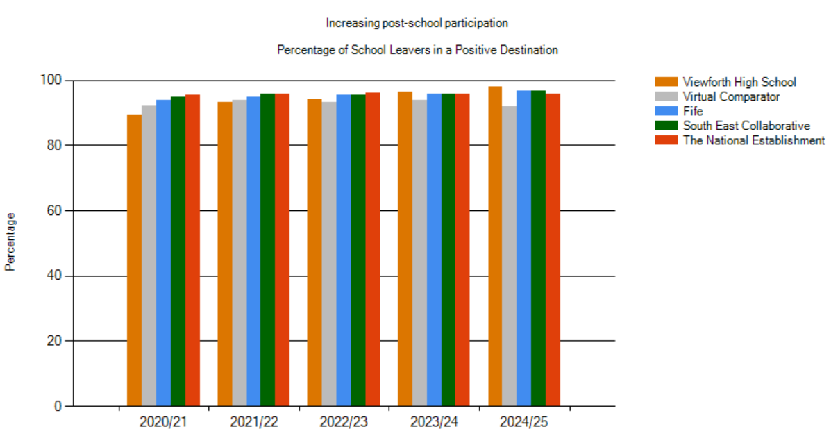
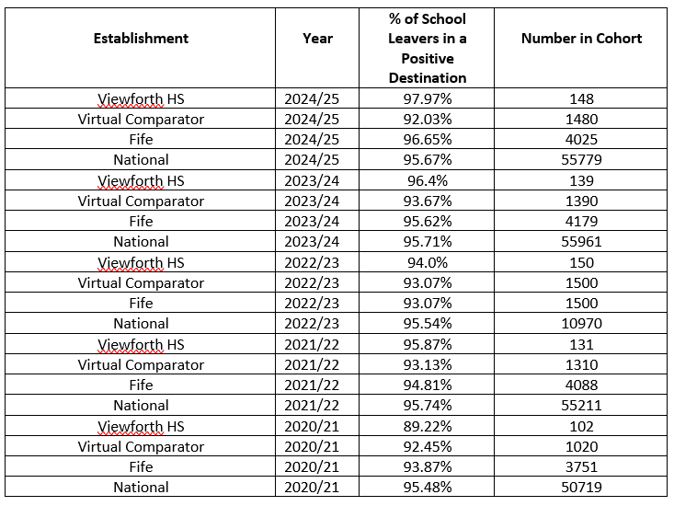
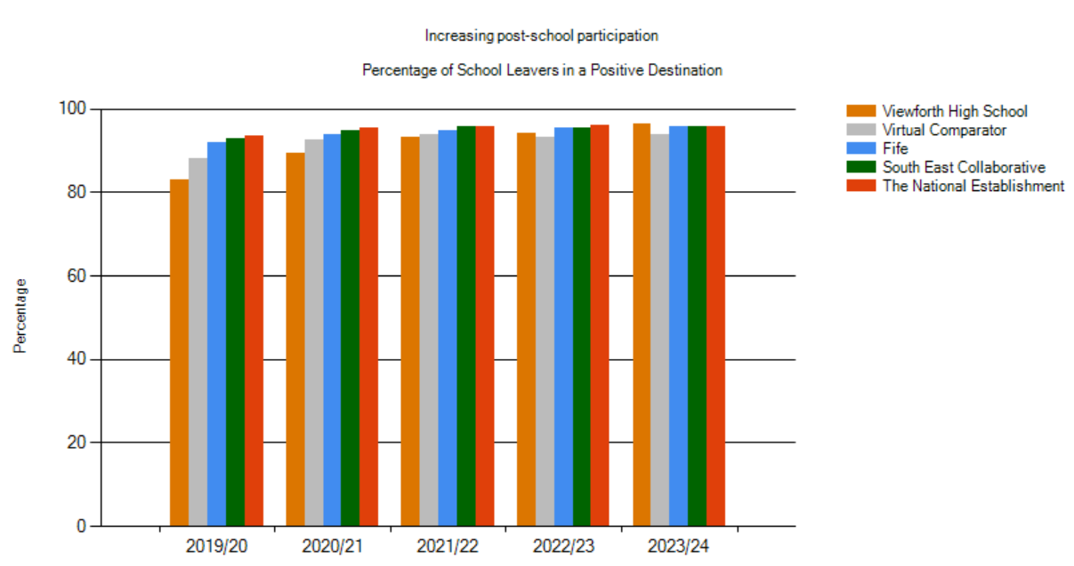

- Almost all leavers (97.97%) transitioned into a positive destination when they left school (2024/25). This was above our virtual comparator (92.03%), above the Fife figure (96.65%) and above the national figure (95.67%).
- The percentage for 2024/25 was the highest that Viewforth HS has had in the past 5 years. A significant increase from 89.22% in 2020/21.
Achievements

One of our S6 learners was highly commended in the Scottish Schools’ Young Writer of the Year Competition. Her piece which provided a staunch defence of rom-coms and their positive impact on mental health was praised by the judges.

Our partnership with Raith Rovers has continued and 45 young people across S1-S3 engaging on a weekly basis with one of the coaches as part of our Sporting Change project. This is designed to support their skills in communication and critical thinking.

Eight S2 pupils attended the CGI STEM event in St Andrew’s, where they engaged in activities with STEM employers. The VHS group won a competition, securing £500 worth of equipment for the school and a series of individual awards. The pupils demonstrated increased confidence, teamwork and resilience and we have seen an improvement in engagement with STEM learning on their return to school.

Seven of our S4 learners participated in the Scottish Actuarial Innovators Challenge, achieving a recognised participation award. Those involved developed their numeracy, data interpretation, teamwork and communication skills, contributing effectively within a collaborative problem-solving context.

This session the Youth Philanthropy Initiative was delivered through our S2 Business and ICT course. 23 young people presented to staff and pupils in the final and the winning group of two pupils, earned £3,000 for their chosen charity – Samaritans Kirkcaldy branch. The S2 pupils responded very well to the programme and report their skills of creativity, communication and leadership have improved as a result of their involvement.

60 pupils from S4 – S6 completed and passed their Level 6 SCQF Emergency First Aid at Work qualification with FAST training. The feedback from the young people was very positive with almost all reporting that they now know what to do when faced with an emergency situation.

The number of young people working to complete the Duke of Edinburgh Awards has continued to grow in VHS with 24 pupils currently engaging with the programme across all three levels, including five working towards Gold. Those involved presented to parents / carers this session and their skills of adapting, demonstrating initiative and communication are evident.

One of our S5 pupils secured a CAD industry placement related to his Graphic Communication course. Daniel secured this placement through a mentor programme, and he attended once per week demonstrating his commitment to developing skills for work.

Four teams (12 pupils) entered the Junk Kouture Competition which is a recycled fashion design competition, supported by the Art and Design department. The young people had to research, design, create and model a couture fashion design made entirely from recycled materials. Two of the designs were selected by the judges to progress to the UK final which was streamed live on YouTube. Unfortunately, they didn’t progress to the world final but there’s always next year.

16 of the young people completing the Sports Leader course had the opportunity to plan and deliver a series of Cluster League Competitions for our four Cluster Primary Schools. This was an opportunity for the pupils to use the skills they have developed as part of their course when working with younger pupils, including communicating, leading and adapting.

Our Skills for Work Hospitality course continues to be very popular with successful outcomes for learners. This year, 40 pupils delivered a series of events for staff and parents as part of their course. These events were an excellent opportunity to demonstrate their skills in a real-world context and the pupils reported feeling very proud following the events.

Evaluations (School)
 | 2023-24 | 2024-25 | 2025-26 | Inspection Evaluations  (since August 2024)
1.3 Leadership of Change | Satisfactory | Satisfactory | Good | N/A
2.3 Learning, teaching and assessment | Satisfactory | Satisfactory | Satisfactory | N/A
3.1 Ensuring wellbeing, equity and inclusion | Satisfactory | Satisfactory | Good | N/A
3.2 Raising attainment and achievement | Satisfactory | Satisfactory | Satisfactory | N/A

Viewforth High School Improvement Plan 2026 - 2027
Education Directorate Improvement Plan: Improving Learning, Teaching and Assessment
Focused Priority 1:
- Support and enhance the delivery of consistently high-quality learning, teaching and assessment through professional learning for all staff focusing on questioning, deepening thinking and the use of digital technologies.
- To support all staff through the use of digital technologies to create a more inclusive, engaging and personalised learning environment leading to improved outcomes for children and young people.

HGIOS4 Quality Indicators
1.3 Leadership of Change
2.2 Curriculum
2.3 Learning, Teaching and Assessment
2.4 Personalised Support
2.6 Transition
3.2 Raising Attainment and Achievement
3.3 Increasing Creativity and Employability
Expected Impact | Strategic Actions Planned |  | Responsibilities | Measure of Success | Timescales
Young people from S1 – S6 will experience improved high quality, planned questioning which is leading to improved understanding and depth of knowledge.  By December 2026, all staff will apply their knowledge of how to personalise learning using a range of digital skills and accessibility tools, leading to almost all pupils having their needs met.  By June 2027, all staff will track young people’s progress across the BGE and will use a range of assessment evidence and moderation to support robust professional judgements across all eight curricular areas.  The progress of all BGE learners will be mapped across all eight curricular areas (from P7 – S3) using Didbook, leading to parents and pupils having a clearer understanding of where a young person is in their learning and their next steps for success.  Almost all young people will be able to confidently articulate where they are in their learning and their next steps for success. | - Professional Learning Activity  - All teaching staff will engage in professional learning with Mark Burns (Plus One Learning Cycles) focused on questioning and deepening learning.  - All teaching staff will reflect on their developing practice linked to the Mark Burns programme and will share this practice at calendared faculty meetings with the support of their PTC.  - All teaching staff will engage in professional learning designed to revisit, consolidate and strengthen their understanding of how to use digital technologies to personalise learning using the range of accessibility tools available.  - All teaching staff will participate in the following activities as agreed in the WTA and School Calendar:  - five faculty moderation meetings  - two Kirkcaldy Collegiate moderation afternoons  - one Fife Council moderation afternoon  - All teaching staff will develop their awareness of and confidence in using the Fife Progression Pathways to support professional assessment judgements in the BGE.  - Learning, Teaching and Assessment  - The use of questioning and the identified ‘plus ones’ from the Mark Burns programme will be a focus of the Sharing the Learning visits across the school.  - All staff will have access to a directory of accessibility tools with links to identified pupils who will benefit from using these.  - The use of digital technologies, including accessibility tools for young people with ASN, will be the focus of Sharing the Learning visits and PTC Walkthroughs.  - The assessment timelines for all faculties will align with the tracking and reporting calendar for both BGE and SP.  - All faculties will follow the VHS Moderation Policy and will complete the VHS record of moderation activities.  - All pupils in both the BGE and SP will participate in learning conversations with their class teachers reflecting on their progress and their next steps for success, supported by the VHS Learning Conversations proforma.  - Enhancing Learners’ Experiences  - All digital resources across the school for pupils in S1 – S3 will be Showbie based, supporting young people and parents/carers to access resources and develop their confidence in using the platform.  - Summaries of Supports will be reviewed as per the schedule to include digital accessibility tools that will support the individual young people with their learning. |  | - S Kowbel  All teaching staff  - S Kowbel  PTCs  All teaching staff  - S Kowbel  K Cunningham  All teaching staff  - S Kowbel  PTCs  All teaching staff  - S Kowbel  M Darling  All teaching staff  - S Kowbel  SLT  PTCs  - S Kowbel  SfL staff  K Cunningham  - S Kowbel  SLT  PTCs  - M Darling  PTCs  - S Kowbel  - D McDonald  M Darling  All teaching staff  - S Kowbel  K Cunningham  PTCs  All teaching staff  - J Wilson  L Hill  SfL staff | Data  - Results from the Glasgow Motivation and Wellbeing Profile conducted twice per year with a particular focus on young people with an ASN.  - BGE Attainment data across all curricular areas from Didbook.  Views  - Staff feedback following engagement with the Mark Burns programme.  - Minutes of faculty meetings.  - Staff views gathered in relation to confidence in using digital technology to personalise learning compared to data from 2025-26.  - Feedback from staff following moderation sessions.  - Young people’s views gathered through class groups and pupil focus groups on questioning, learning conversations and the use of digital technologies:  - S1 highest 20% & lowest 20%  - S2 ASN  - S3 middle 60%  - S4 cusp pupils  - S5/6 FSM/SIMD/CE  Observations  - Sharing the Learning Visits and PTC Walkthroughs linked to the use of digital technologies and high-quality questioning. | 1a. 18.08.26  10.02.27  26.05.27  1b. Faculty Meetings as per school calendar.  1c. 01.10.26 and other dates as per staff CLPL calendar.  1d) Faculty Moderation  Wb 05.10  Wb 07.12  Wb 25.01  Wb 08.03  Wb 17.03  Kirkcaldy Collegiate  18.09.26  21.05.27  Fife Council Session  10.02.27  1e) April 2027 – progress check Feb 2027  2a) As per StL calendar visits pre and post Christmas  2b) December 2026  2c) As per StL calendar visits pre and post Christmas  2d) December 2026  2e) Faculty Moderation  Wb 05.10  Wb 07.12  Wb 25.01  Wb 08.03  Wb 17.03  Kirkcaldy Collegiate  18.09.26  21.05.27  Fife Council Session  10.02.27  2f) Prior to each reporting window as per the school calendar.  3a) November 2026 – progress check September 2026  3b) December 2026 – progress check October 2026
Ongoing Evaluation
This should be updated as part of on-going cycle of self-evaluation

Education Directorate Improvement Plan: Meeting Learner’s Needs
Focused Priority 2:
- To strengthen the Viewforth High School Continuum of Support with a particular focus on universal support.
- To support all staff through high quality professional learning in the use of the Circle Inclusive Classroom Scale (CICS) and Relational Practice to meet the needs of learners accessing timetabled settings.

HGIOS4 Quality Indicators
1.3 Leadership of Change
2.3 Learning, Teaching and Assessment
2.4 Personalised Support
3.1 Ensuring Wellbeing, Equality and Inclusion
3.2 Raising Attainment and Achievement
Expected Impact | Strategic Actions Planned |  | Responsibilities | Measure of Success | Timescales
By June 2027, the majority of young people in S1 and S2 will experience (within their timetabled lessons) a universal package of support that meets their needs and enables them to actively engage in their learning.  By December 2026, almost all staff understand how to, and can apply, relational practice in their settings and in their planning to meet young people’s needs.  By June 2027, all staff will have used the Circle Inclusive Classroom Scale (CICS) to evaluate their classroom environments, leading to a positive impact on young people, including on their attendance and engagement. | 1. Professional Learning Activity  - A directory detailing the profile of the needs of our learners will be created for classroom teachers, support for pupils and guidance staff to support them to meet the needs of learners within their settings. Data (including GWMP, ASN, NGRT, CAT, CEM and NSA data) alongside a knowledge of our pupils will inform this directory.  - All staff alongside colleagues from the Cluster will engage in relational practice professional learning provided by Suzanne Zeedyk, in line with the Cluster Improvement Plan.  - A series of CLPL inputs will be offered to all staff as part of the VHS CLPL calendar in response to targets identified from PRD meetings and the recent Staffwise survey.  - All staff will participate in professional learning with the support of the Supporting Learners Service on how to use the CICS and a VHS specific guidance document will be produced to support staff and supplement the training.  - The implementation of the CICS will be a standing item for faculty meetings to support staff to engage with and review the process.  - All teaching staff will be provided with the opportunity to moderate the learning environment across faculties and the wider school.  2. Enhancing Learner’s Experiences  - In response to professional learning (CIRCLE), all teaching staff will participate in a test of change with an identified class / group of young people as agreed through discussion with their PTC.  - Learning, Teaching and Assessment  - Learning environments will be considered as part of the Sharing the Learning Visit process and discussed with staff during the feedback sessions. |  | - J Wilson  L Hill  SfL staff  PTGs  - J Wilson  C Beesley  Shadow Cluster Group  All teaching staff  - J Wilson  S Kowbel  L Hill  SfL staff  PTGs  - J Wilson  SL Service staff  - J Wilson  PTCs  All teaching staff  - J Wilson  PTCs  All teaching staff  - J Wilson  PTCs  All teaching staff  - S Kowbel  SLT  PTCs  All teaching staff | Data  - Glasgow Motivational and Wellbeing Profile – completed with all young people twice during the session.  - Attendance data incl. ARAs.  - Exclusion data.  - Standardised data incl. NGRT, CAT, CEM & NSA  - ASN data  Views  - Minutes of faculty meetings  - Staff views regarding the directory of supports, the impact of the tests of change and the learning environment across the school  - Staff views gathered following professional learning sessions  - Pupil feedback regarding their learning environments and how their needs are being met within their timetabled classes  Observations  - Sharing the Learning Visits will consider the learning environment in line with the CICS. | 1a) December 2026 – progress check October 2026.  1b) 13.11.26  1c) As per the CLPL Calendar  1d) 17.08.26  1e) Faculty Meetings as per school calendar.  1f) As agreed through discussion with DHT link and PTC.  2a) Test of change identified by September 2026, complete by March 2027 – progress check January 2026.  3a) As per StL calendar visits pre and post Christmas
Ongoing Evaluation
This should be updated as part of on-going cycle of self-evaluation

Education Directorate Improvement Plan: Strengthening Our Curriculum Pathways
Focused Priority 3:
- To increase opportunities for young people in S1 and S2 to deepen and consolidate their learning through homework, issued in a fair and equitable manner using Showbie.
- To support all staff to prepare for the transition to the Curriculum Improvement Cycle.
HGIOS4 Quality Indicators
1.3 Leadership of Change
2.3 Learning, Teaching and Assessment
3.2 Raising Attainment and Achievement
Expected Impact | Strategic Actions Planned |  | Responsibilities | Measure of Success | Timescales
All pupils in S1 and S2 will experience homework across all curricular areas, leading to an increase in opportunities to deepen and consolidate learning and receive feedback. The homework programme will also support young people to develop independent learning skills which will support them in the Senior Phase of learning.  In line with the timeline for the introduction of the Curriculum Improvement Cycle, all staff will familiarise themselves with the documentation produced and consider this in relation to current course plans and timelines. | - Learning, Teaching and Assessment  - A Homework Standard will be agreed across all departments supporting teachers to issue activities in a fair and equitable manner.  - All activities will be issued using Showbie and all feedback will also be provided via this platform. Where necessary access to paper resources will be provided to ensure equity.  - Parental engagement sessions offered to promote the completion of homework and provide support in relation to Showbie and how to access the work.  - Create a homework club for S1 and S2 learners to support them to complete homework and meet deadlines.  - Faculties will ensure they are familiar with all documents produced in preparation for the Curriculum Improvement Cycle and begin to consider these alongside current course plan and timelines. |  | - S Jamieson  M Darling  - S Jamieson  K Cunningham (training needs)  PTCs  All staff  - S Jamieson  M Darling  C Beesley  - S Jamieson  L Moore  Prefects / Captains  - M Darling  PTCs  Teaching staff | Data  - Baseline measure of number of faculties currently issuing homework and the frequency of this.  - Tracking reports are used to monitor homework returns.  - Attendance at the S1 & S2 homework club.  - Showbie usage statistics.  Views  - Parental views gathered re the amount and quality at the beginning of the year, halfway and towards the end of the session.  - Pupil views gathered re the amount and quality at the beginning of the year, halfway and towards the end of the session.  - Faculty meeting minutes to gather staff views. | - End of term 1  - From beginning of term 2  - Dates TBC during term 2 and term 3. Information to be included in S1 and S2 parents’ evenings.  - End of term 1  - In line with CIC timeline and during faculty meeting discussions.
Ongoing Evaluation
This should be updated as part of on-going cycle of self-evaluation

APPENDIX D - Session 2025-2026 Improvement Plan – PEF Plan

Pupil Equity Fund allocation for session 2025/26 | £ 169,560
School Context
Viewforth High School is located in the east end of Kirkcaldy and serves a catchment area where there are a variety of socio-economic challenges facing the community. At the point of Census in September 2025, the school roll was 655. We have 34 learners within our Enhanced Support Classes, ranging from stages S1 – S6. 33.74% of our school roll is registered for Free School Meals and we have a teaching complement of 63.85 FTE. Viewforth High School shares the Windmill Community Campus with Rosslyn School, a public library, community use and the local community council office.
We have 4 Cluster Primary Schools, Dysart Primary, Kirkcaldy North Primary, Pathhead Primary and Sinclairtown Primary.
The Senior Leadership Team consists of 1 Head Teacher, 3 Depute Head Teachers and a Business Support Manager. There are 6 Principal Teachers of Curriculum and 6 Principal Teachers of Guidance
Our school values were revised during session 2024-2025 and are Respect, Equity, Ambition, Community and Health and we are working to promote these values throughout the school community of VHS. Our school vision is to Work Together, Achieve Together and we endeavour to be the best we can be, in all that we do.
Building the ambition, self-confidence and self-esteem of our young people is very important to us. By working closely as a school community and in partnership with parents/carers, the wider community and partner agencies, we aim to secure positive, sustained destinations for all of our young people. Ensuring that pupils leave school having developed skills for life, learning and work and are ready to contribute positively within society.

Cost of the School Day
At Viewforth High School we recognise the need to reduce the Cost of the School Day for all our young people and particularly for our young people who are already experiencing poverty. We examine the school day through the following headings: Uniform, Travel, Learning, School trips, Eating and Clubs.

All young people have access to free lockers in school, school materials, uniform, sanitary products and toiletries. We provide a free breakfast every morning and this is available to all pupils. When school trips are planned, careful consideration is given to the cost of these, and we ensure that pupils entitled to free school meals are always represented. We have secured funding from Tesco which allows us to provide free fruit to all young people, and this is available first thing in the morning, during interval and again at lunch. Our Family Support Worker and Principal Teachers of Guidance work closely with families to support them to apply for Free School Meals, Educational Maintenance Allowance and other benefits they may be entitled to.
Stakeholder engagement

Discussions have taken place with all staff and members of the Parent Council with regards how our PEF allocation is spent.

Rationale |  |  | Amount of Fund allocated £169,560
Improve levels of attainment and achievement with a focus on literacy and numeracy outcomes. Improve attendance and increase pupil wellbeing.
Expected Impact | Interventions Planned | Measure of Success |  | Impact on children  Ongoing evaluation Dec/June
Intervention 1  To increase the number of pupils in SIMD 1 & 2 leaving school with relevant qualifications to support them to progress into a positive, sustained destination.  To increase the number of pupils in SIMD 1 & 2 leaving VHS with a literacy and numeracy qualification.  Intervention 2  Improve attendance, attainment and engagement along with a reduction in exclusions  Increase the number of pupils leaving school with at least 6 qualifications, including level 4 literacy and numeracy.  Support transition from school into a positive and sustained destination.  Increase the number of tariff points for our school leavers.  Intervention 3  To increase the literacy and numeracy levels of our learners within the BGE.  Intervention 4  To improve educational outcomes for care-experienced young people by engaging with MCR Pathways mentoring programme. | A development post holder will provide targeted support to young people at risk of leaving school without a range of qualifications including literacy and numeracy.  With the support of partner agencies, the post holder will work closely with the young person and their family to develop aspiration, ambition and self-belief at the same time as working to remove any poverty related barriers that may be preventing them accessing their learning.  The development post holder will link closely with the SLT, Guidance Teachers, PTC and the named contact for each curricular area being delivered to enable progress and engagement to be mapped.  Pupil Equity Funding will enable us to hire and staff a local youth club facility to provide a ‘safe space’ for our most anxious learners to access. This will be staffed by identified school teaching and support staff. Targeted pupils will attend at identified times to complete courses and develop the skills required to transition into a positive, sustained destination when they leave school.  The hub will also be used to support pupils back into the school building following periods of prolonged absence etc.  An additional Pupil Support Assistant will support the learning of identified pupils within the curriculum with a particular focus on literacy and numeracy.  A Primary Specialist Transition Teacher will work closely with English and Maths colleagues to upskill them in working with learners within level 1 and the early stages of level 2. The Transition Teacher will teach targeted young people within the BGE to support them improve their literacy and numeracy.  A full time MCR mentor will be based at VHS. This mentor will engage care experienced young people, building supportive and reliable relationships whilst increasing the young person’s self-confidence and self-belief. They will work closely with the young person, Support Team, Partners and families to increase the number of care experienced young people from VHS that transition into a positive sustained destination. | Attendance at school.  Analysis of Insight and CfE data.  Progress in unit assessments.  Attendance & exclusion data:  - Seemis  - Power BI  Insight data: including tariff points & school leaver destination results.  NGRT reading test data  Literacy and Numeracy levels  NGRT reading test data  CAT data  NSA P7 & S3 data  Literacy and Numeracy levels  Insight SLDR  Pupil, parent, staff surveys

APPENDIX E – Pupil Equity Financial Plan Session 2026-2027
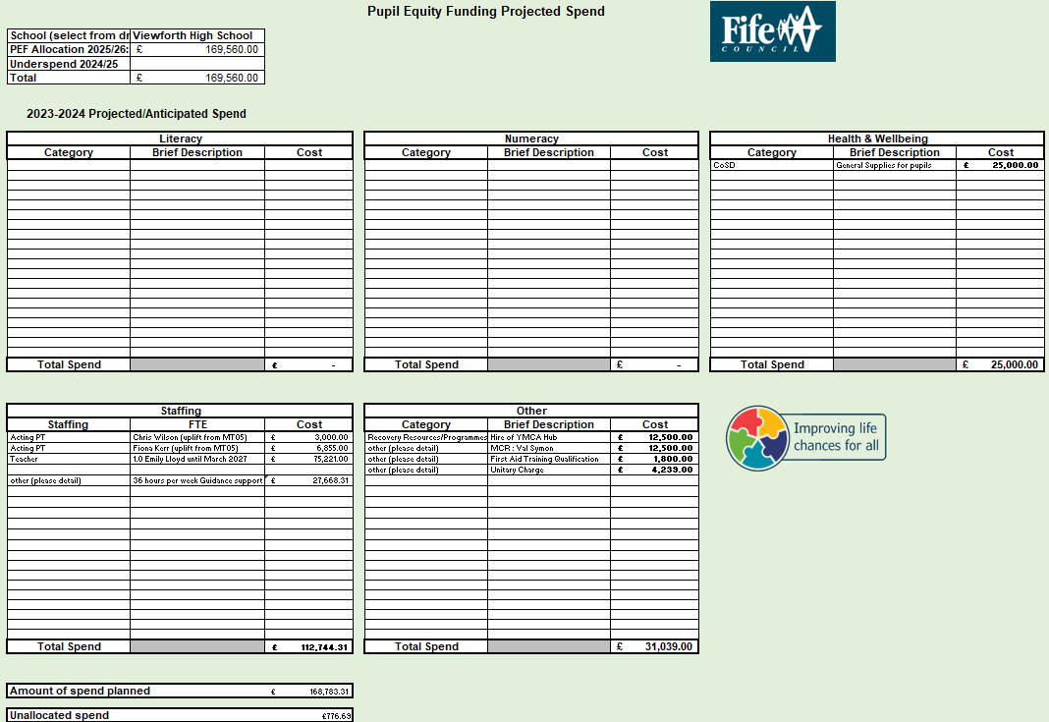

APPENDIX F – OFFICER FEEDBACK

Name of Establishment:

Name of Headteacher:

Education Manager:

Standards and Quality Report Session 2024-2025

Context
Demographic  Vision, values and aims | Completed |  |  | Still to be completed
Attendance | Completed |  |  | Still to be completed
Exclusions | Completed |  |  | Still to be completed
Summary of consultation with stakeholders | Completed |  |  | Still to be completed
Attainment Scotland Fund Allocation (PEF) | Completed |  |  | Still to be completed
Cost of the School Day statement | Completed |  |  | Still to be completed
Summary of consultations with stakeholders | Completed |  |  | Still to be completed
Progress and Impact
Priority 1 | Fully achieved |  | Partially achieved |  |  | Continued next session
Progress  Clear progress has been made with strategic actions | Comments:
Impact  Clear impact shown for children and young people | Comments:
Next Steps  Limited number of next steps | Comments:
Priority 2 | Fully achieved |  | Partially achieved |  |  | Continued next session
Progress  Clear progress has been made with strategic actions | Comments:
Impact  Clear impact shown for children and young people | Comments:
Next Steps  Limited number of next steps | Comments:
Priority 3 | Fully achieved |  | Partially achieved |  |  | Continued next session
Progress  Clear progress has been made with strategic actions | Comments:
Impact  Clear impact shown for children and young people | Comments:
Next Steps  Limited number of next steps | Comments:
Add more rows as required

Improving Outcomes
Attainment Overview Completed | Comments:
Evaluative Statement about Attainment | Comments:
PEF Progress and Impact reported | Comments:
Wider achievement – impact on children and young people  Personalised for schools and significant events/achievements shared | Comments:
Evaluations(6-point scale) | Comments:
External Feedback | Comments:

Improvement Plan Session 2025-2026

Comments
Are priorities identified supporting recovery?
- Do they cover school, ELC and ASC?
Are relevant QI’s identified for priority identified? (including Early years if relevant)

Expected impact

- Is this focused on children and young people
- Is this written evaluatively
- Is this linked to data
Strategic Action/tasks identified:
- High level
- Realistic
Responsibilities
- Identified
- At all levels
Measure of Success (including Triangulation of evidence/QI Methodology)
- Is there evidence that evidence will be gathered from different stakeholders and through different ways throughout the session.
Timescales
- Realistic
PEF Plan (included)
PEF Financial Plan (included)

Feedback given by:

Date feedback given:

